Delphi 3
Persistence Pays Off!

By Robert Vivrette

Your parents always taught you to be persistent. That is the only way to get noticed these days! Well, persistence is not just a good quality for us humans! Computer users have come to expect a certain level of persistence in the programs they use.

Think about the applications you use every day… No doubt each one has its own little problems with persistence that just annoy you each time you use them. I use CompuServe for Windows to manage my CompuServe mail and am always irritated at the number of places within the program where I have to do repetitive tasks over and over again. When I launch the program, it never leaves me where I left off. I have to click on the Mail Center button to look at my list of incoming mail. Whenever I add attachments to messages, the Open dialog is never looking at the right directory. Virtually every program I use has these kinds of minor shortcomings. I am sure that when they were developed, saving the existing state of certain controls was not considered a priority. Many programmers in fact consider it to be “programming drudgery”.

Yet programming an application to be persistent is a vital piece of your job as an application developer. Your application might be the greatest thing since they put soap in Brillo pads, but if it requires users to unnecessarily provide repetitive input to the program, it will quickly become an annoyance. Here are just a few of the kinds of information that a program should save.

- User information (Name, address, passwords, etc.)
- Sizes and locations of forms (including the main application form)
- States of program options
- History lists of file Open and Save dialogs
- Last directory visited by Open and Save dialogs
- History list of recently accessed document files
- Custom wild-cards specifications for file Open and Save dialogs
- Typefaces used in the application.
- Last visited tab in tab-sheet controls

As you can see, the list is unending and I could probably go on for hours with additional items. Probably the best indicator of when you have a problem with persistence is to watch a user run your program over and over again. How many times did they have to perform the same steps? How many times did they have to resize a form, or change to another tab in a tab-sheet. Every place where there was a repetitive action is a place where you could save that state from the previous execution of the application.

The Registry

32-bit Windows provides all of us with an excellent place to store persistent data. It is an internal database of information managed by Windows called the Registry. Before the Registry existed, application developers stored persistent data in INI files. While that technique can still be used, it is no longer recommended. The Registry adds capabilities that don’t automatically exist in INI files (such as storing data for different users of the same machine).

However, some habits die hard and many application developers still like using INI files. For the purpose of this article, we are going to be dealing with just the Registry, but if you are stuck on INI files (or are developing 16-bit applications) the same principals apply to INI files.

The format of the Registry is a deeply nested tree structure. Each branch of a tree (or ‘key’ in Registry terminology) holds information about a particular user, or application or piece of hardware. At the end of these keys, you will have Name/Value pairs. This is where persistent data is actually saved. For example at the HKEY_CURRENTUSER\ControlPanel\Colors key, you have a list of key names (such as ActiveBorder, ActiveTitle, AppWorkspace, etc.) that have color assignments as values. When you open the control panel and access the colors applet, Windows retrieves these color assignments as your most recently selected color options.

This article however will assume that you have a basic understanding of how the Registry works, and before we go much farther, I will provide a warning… The Registry holds data essential to the operation of Windows itself. If you don’t know what you are doing and you accidentally corrupt data in the Registry, you quite possible might render Windows inoperative. Therefore, please make certain you understand how the Registry functions and make backups of the registry prior to doing any questionable experimentation. Windows 95 and NT also have a program called RegEdit that you can use to manipulate the Registry database. The online help for RegEdit will help you if you have questions on its use. Okay.. with that out of the way, let’s go on.

So we want to save persistent application data and we want to use the Registry to hold that data. How can you get a component to save pieces of itself (properties, values, etc.) automatically? Well, there have been many efforts in the Delphi community to create persistent objects and so that we understand the issues a bit more, lets look at some of these along with their advantages and disadvantages:

Subclassed Registry-Aware Components

In this scheme, a developer creates a component that is aware of the Registry and has the ability to save and load data to and from the registry. Say for example that you wanted an Edit box that automatically saved the value of its Text property to a certain registry key. Using this technique, you would create a new component (descended from a TEdit) and added support for the registry. This support would likely be in the form of two methods (one each to save and restore the Text property to the registry), as well as some new property that lets the user define what key to use in the registry.

The end result would be something named like TRegistryEdit. It would look and behave exactly like an Edit field, but would have one additional property (perhaps named "RegistryKey"). To use the control, a developer simply takes a TRegistryEdit control, drops it on the form, provides the name of a key in RegistryKey and then adds a line of code in the FormCreate and FormDestroy to access the registry load and save methods of the new subclassed control.

What are the disadvantages of such an approach. Well, to be honest there are plenty. The key one is that you have to create a new subclassed control for every component that you want to add registry support for. If you want to add registry support to ListBoxes, ComboBoxes, StringGrids, RadioButtons, and CheckBoxes, you will have to create a new subclassed control for each of these and add the same registry support code that you did for TRegistryEdit. The code that you add would be essentially identical, but would of course save the checked state of a checkbox and radio button, the list of items in a ListBox and ComboBox, etc. However, when you add all these new controls to your form, you are adding quite a lot of redundant registry support code. Remember, each subclassed control you added had its own registry support! Also, your component palette will have to house all these new registry-aware components.

In addition, you still will need to manage (in code) each of these controls. Your FormCreate method might start to look like this:

procedure TForm1.FormCreate(Sender: TObject);
begin
Edit1.LoadFromRegistry;
Edit2.LoadFromRegistry;
Edit2.LoadFromRegistry;
Edit2.LoadFromRegistry;
ListBox1.LoadFromRegistry;
StringGrid1.LoadFromRegistry;
CheckBox1.LoadFromRegistry;
CheckBox2.LoadFromRegistry;
CheckBox3.LoadFromRegistry;
CheckBox4.LoadFromRegistry;
CheckBox5.LoadFromRegistry;
end;

Obviously, this adds a lot of maintenance responsibilities when developing the application and will be prone to error (particularly if you are saving and restoring dozens or hundreds of values).

Another disadvantage with this approach is that the new registry-aware control is only going to save data that you as the component developer programmed it to save. For many controls it is obvious: A TEdit saves its Text property, a CheckBox saves its Checked state, and so on. But what if someone using your registry-aware control wants to save the TEdit’s ShowHint property, or the CheckBox’s Enabled property? They probably would have to toss your control and make their own subclassed version saving the values that they want to save. Obviously, this is not a great example for promoting code re-use.

Now, granted this kind of idea could have worked only if the Delphi development team decided to add automatic registry support into the component hierarchy. They could have added some kind of RegistryKey property in the TPersistent class (or somewhere else nearby) and then all components descending from it would have that same basic behavior. However, it would have clearly made the VCL a bit more cluttered. Who knows… they may have not even thought of it. Regardless, it isn’t there now so we have to find another solution…

A Better Solution

Let’s step back a bit and look at the problem with a broader perspective. We want to save data related to controls, but as we learned above, we don’t want to have to create new registry-aware versions of each control. This means that our improved solution has to work with unmodified components and should require the absolute minimum amount of maintenance.

Enter the Persistent Object Manager (ObjMgr). For those of you who have used my IniOut Component Property Manager, the Persistent Object Manager will seem very familiar. Although IniOut is a shareware product, I wanted Delphi programmers to get a feel for some of the concepts it uses. As a result, I created a completely new component, based loosely off the ideas used in IniOut. That way, I can provide all the source code necessary to show you how it works in this article without sabotaging the future success of IniOut.

First, let’s go through a brief example of how ObjMgr works. After we get a good idea of how ObjMgr works, we can then dig into how it is implemented in code.

Using The Persistent Object Manager

Let’s say we are writing a simple piece of code that will save the name of the programs user and some other related details. This form might look something like Figure 1:

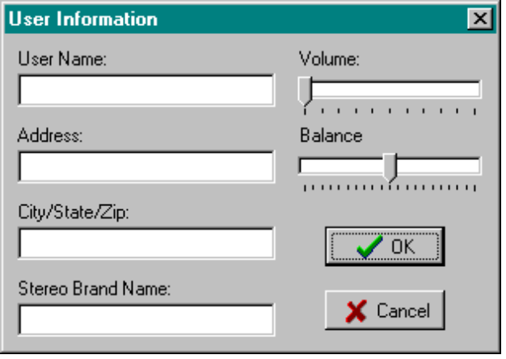
Figure 1

The first time your application runs, you want to gather this information and save it to the Registry. You will probably also want the ability for the user to get back to this form to modify or update the information. Granted, you could just create an instance of a TRegistry Object and write out the values when the form closes and read them back in when it opens again. However, the whole objective here is to not have to write or manage this kind of code, particularly for each component on the form.

Instead, let’s add an ObjMgr component to the form. It is a non-visual component and once you place it on a form and double-click it, you will see the following property editor:

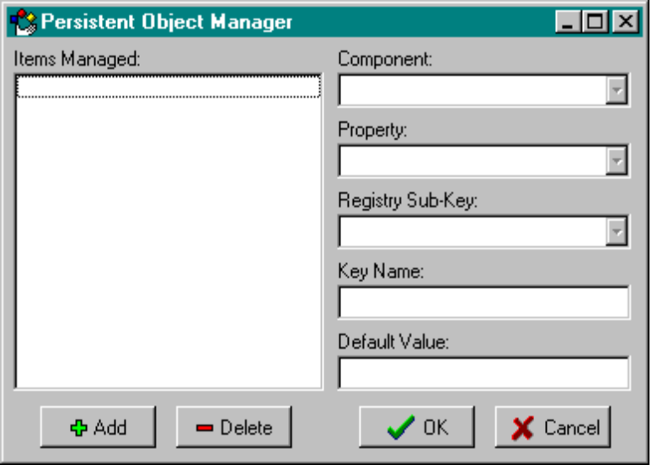
Figure 2

This is the project we are going to create in this article. The ListBox on the left shows what component properties you are managing. For each item managed, you will provide data in the controls on the right. We add a new item by clicking on the Add button. The Component combo box let’s you pick a control on the current form. Note that by dropping down this combo box, we automatically see all the controls that are present on the form (see Figure 3)

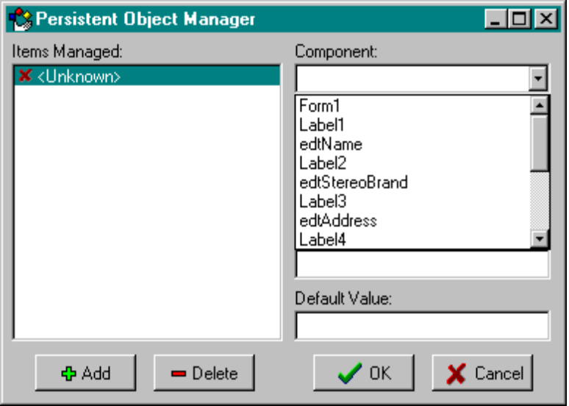
Figure 3

First, we will start with the User Name edit box (edtName). When you pick that, component, the Property combo box now is populated with all the supported properties of that edit control (see Figure 4)

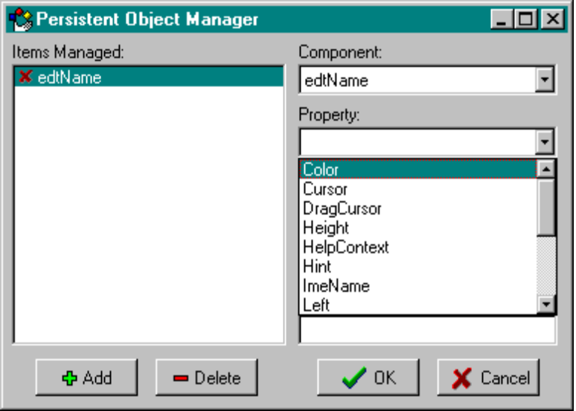
Figure 4

In this case, we want to manage the Text property for this edit control. After choosing this property, we next provide the Registry subkey that this value will be saved as. Let’s enter ‘Software\Informant\ObjMgrDemo\UserData’ for this value. Then, you provide the Name of this particular key… in this case we will call it ‘UserName’. Lastly, we have a field that allows us to provide a default value for the property. It wouldn’t make sense to provide a default for a user name so we will leave this blank. After all these steps have been done, the property editor would look like this:

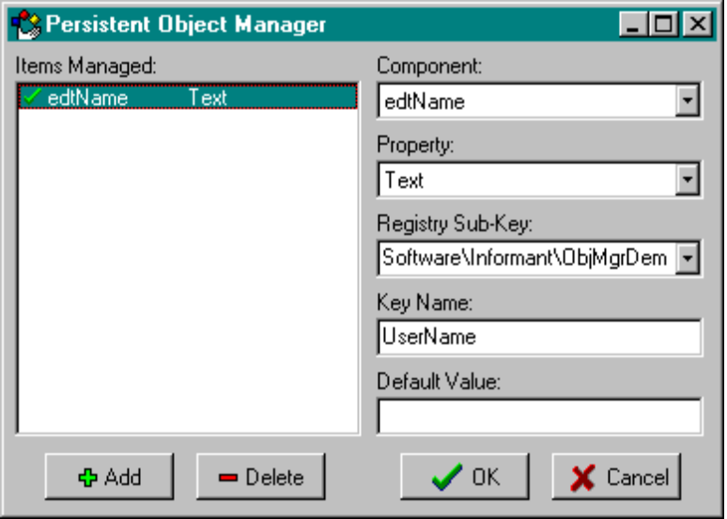
Figure 5

Now, let’s add all the other items we want to manage. Specifically, we would want to save the Text properties of the Address, City/State/Zip, and Stereo Brand Name edit boxes. Also, let’s save the Position property of each of the two track bars (Volume and Balance). Note that the Registry Subkey value will be the same for each item. More on this later… After specifying each of these, the property editor would look like Figure 6:

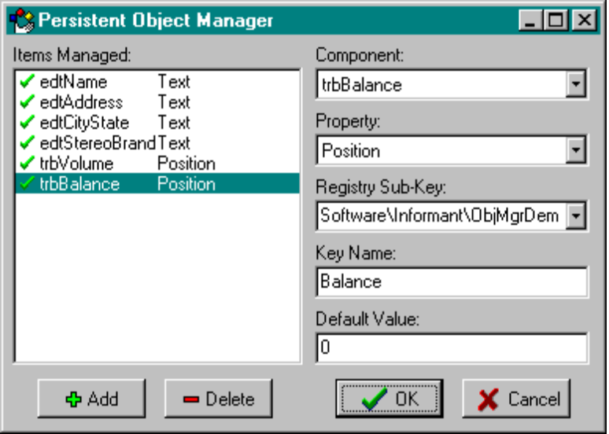
Figure 6

We dismiss the property editor by clicking OK. Now there is only one thing left to do… We need to tell ObjMgr when to read values from the Registry and when to save them back out. The FormCreate and FormDestroy are good spots for these. All we do is add a single line of code to each to access the Load and Save methods of ObjMgr as follows:

procedure TForm1.FormCreate(Sender: TObject);
begin
ObjMgr1.Load;
end;

procedure TForm1.FormDestroy(Sender: TObject);
begin
ObjMgr.Save;
end;

Now run the application… (see Figure 7)

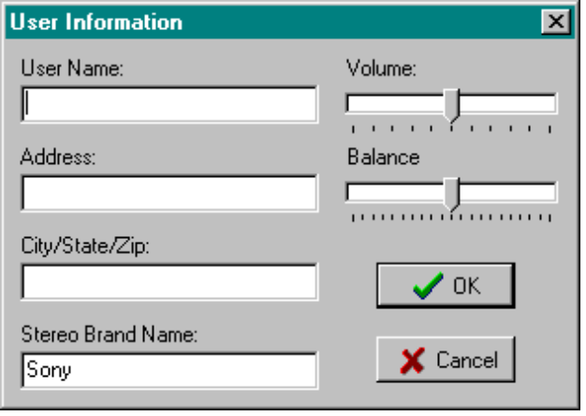
Figure 7

See what happened? ObjMgr setup the form as we requested through its property editor. Since this is the first time the program has been executed, there is no entry in the Registry for any of this data. Therefore each control was given its default values. Now lets enter data in each field and then close the application. (see Figure 8)

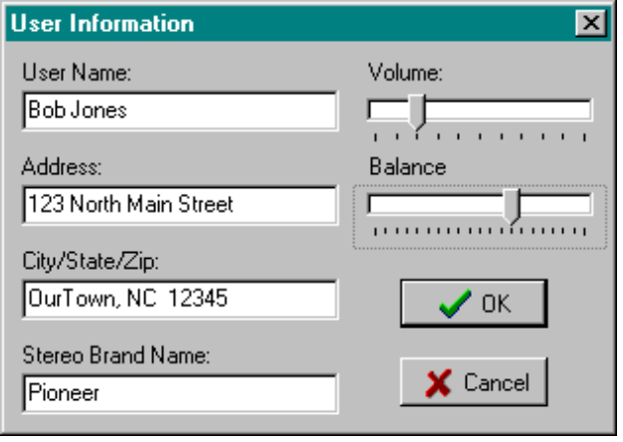
Figure 8

When the app closed, the FormDestroy method was triggered which told ObjMgr to Save its managed properties to the Registry. Now, if you run RegEdit you will note that the following registry data has been entered: (see Figure 9)

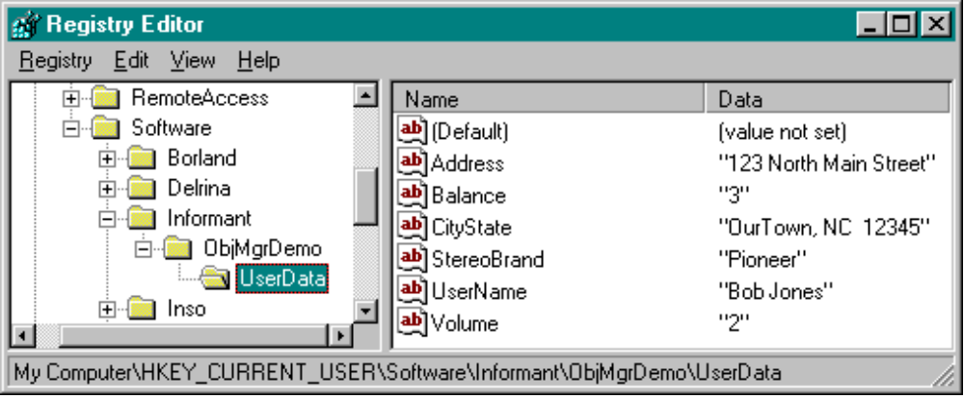
Figure 9

The location of these keys comes of course from the Sub-key field data we provided to ObjMgr. Now comes the cool part… Run the program again… See what happened? This time, since the registry key existed along with all the values we provided to ObjMgr, each of the controls has been restored to how it was when the form last closed. This is because we told ObjMgr to Load its values in the forms FormCreate method.

Keep in mind that all we needed to do to accomplish this was to add an ObjMgr component to the form, use its Property Editor to provide some basic information of properties to manage, and then added 2 lines of code (1 each in the FormCreate and the FormDestroy). We used stock controls off of Delphi’s component palette and turned them into persistent objects. Not bad! Further, if you were to expand on the form to hold a few more controls, and you wanted to save property values from those controls, you only need to access ObjMgr’s property editor and add those items!

How It Works

Now that we’ve seen ObjMgr at work, let’s check under the hood to see how it works. I won’t be covering every aspect of ObjMgr, but rather just hitting all of the highlights. But fear not! If you want to use ObjMgr yourself, the complete source code is available at Informant’s web site noted at the end of this article.

The key piece of ObjMgr is of course the property editor that you see when you double-click on the component (Figure 2). The whole purpose of this property editor is to manage the contents of a single TStrings object. This string list holds the essential bits of information necessary for ObjMgr to save and restore properties from the Registry. Although this list is internal to the component and you really never see it directly, a brief discussion of its structure would I think be beneficial:

Each item in this string list holds information for a single property being managed. The string is a collection of smaller strings separated by commas. The pieces of each string list item are as follows:

- Component Name
- Property Name
- Registry SubKey
- Key Name
- Default Value
- Valid Flag

In our discussion above, therefore, the first item that we entered into ObjMgr would be stored internally like this:

edtName;Text;Software\Informant\ObjMgrDemo\UserData;UserName;;1

First, there is the Component Name (edtName) then a semi-colon, followed by the Property Name (Text) and another semi-colon and so on. Towards the end, you see two semi-colons together. This is where the Default is stored, and for edtName we didn’t provide one. Lastly, there is a ‘1’, which is a flag to tell ObjMgr whether the item is valid or not. If the item is valid, it is included when saving or restoring from the registry. If it is not valid, it is skipped.

With that piece of architectural design behind us, let’s move on. When the ObjMgr is activated, how does it get the list of components from the form? Well, as it turns out the creators of Delphi knew that component developers would want this feature. These capabilities are all collected under one main concept, namely what Borland calls RTTI – Run Time Type Information. This is a mechanism in the internal structure of Delphi that allows you to interrogate any component at runtime. You can see the components name, a list of properties and methods, etc. RTTI is essential for the design-time pieces of Delphi to work, and ObjMgr relies heavily on RTTI to work its magic. If you want to learn more about RTTI, I would recommend looking through the Delphi units TYPINFO.PAS and DSGNINTF.PAS. Both of these files are reasonably well documented and many of the procedures mentioned therein are also referenced in the Delphi Help system.

So to get the list of components on the form, we need to talk to RTTI. We first do this in the FormShow method of the property editors form (see Listing 1). The first step there is to add the name of the form itself to the Components combo box. This will allow us to get access to the form’s properties. Next, we need to get a list of all the components on the form. This is done by means of a reference to the Form Designer which is defined in Delphi’s DSGNINTF.PAS unit. Basically this is a way that a property editor can obtain a connection to the form that is currently in use. In our case, we use this reference to get access to the Form’s Components array. We simply loop through all the elements of this array and add each components name to the Components combo box.

Once a component is selected out of this list, we need to get a list of its properties to populate the Properties combo box. After a user has chosen a Component (actually on its OnChange event) we call the UpdatePropertiesCombo method. The first line of code in this method extracts out the currently selected item from the Items Managed ListBox (the compound strings we were talking about earlier). I then use a short function called Parse to extract out the individual piece we are looking for… In this case, the name of the Component. Referring back to the Form Designer again, we obtain a reference to the component (which can be either a component on the form or the form itself).

Next, we use the GetPropList function in Delphi’s TYPINFO.PAS unit. This function returns all properties matching a certain criteria in its class or its ancestors. That criteria is a set of the supported property types ObjMgr can handle (specifically [tkInteger,tkChar,tkString,tkLString]). If you call this function and provide a ‘nil’ in the last parameter, the function simply returns the number of properties that the component has. After we have this count, we allocate a chunk of memory of the appropriate size and then call the function again – this time including a pointer to that block of memory. Then it is just a matter of scanning through this block of data (records of type TPropInfo) and extracting the name of each property we encounter. After that we make sure that we free the memory block. That whole section is wrapped in a try..finally construct to make sure this happens.

Briefly then, whenever a user clicks on an item in the Items Managed ListBox to the left, ObjMgr needs to fill each control on the right with the appropriate data (if available). Obviously, if you are adding a new item to the list, some of the controls will have no data to display. But after you have entered a few items, you will be able to scroll up and down the list and all the controls on the right would be automatically updated. The effect is much like data-aware controls, but there is of course no database involved here. In the preceding paragraphs, I discussed how UpdatePropertiesCombo works, but there is actually a similar Update method for each of the controls on the form. This is shown in Listing 3.

One additional routine I wanted to comment on was NewRegSubKeyCheck. This method is called whenever the user hits the enter key in or exits the Registry Sub-Key field in the property editor. What we want done is that the drop-down list should show a list of all subkeys that have been entered so far. This routine looks at any entry into the drop-down combo and checks to see if it already exists in the list. If it does, that item is selected. If it doesn’t, the new string is added to the list. This is a good general purpose routine for this kind of drop-down combo box management.

The code for ObjMgr is split up into two units: OBJMGR.PAS and OBJMGR2.PAS. The first unit houses all the behavior of the property editor as a whole – i.e. the way the controls work, the way it allows you to add and delete items managed, and so on. The second unit, OBJMGR2.PAS contains the internal string list of managed properties as well as the Registry support code. When you install ObjMgr into the Delphi Component Library, you are adding OBJMGR.PAS which references OBJMGR2.PAS. However, at runtime, the only file that needs to be included in a project is OBJMGR2.PAS. Since that is where the internal string list and registry code are, Delphi knows that it doesn’t need to link in all of the design-time material into your runtime executable. If you looked at the compiled DCU files for each of these units, you would see that OBJMGR.DCU is about 17K in size and OBJMGR2.DCU is only 6K in size. Since the design-time and run-time material has been segregated in this way, we save the 17K of OBJMGR.DCU that doesn’t link into the final executable.

So that leads us into the run-time piece of the code, OBJMGR2.PAS shown in its entirety in Listing 5. The unit is very straight-forward. First, there is the definition of TObjMgr (which descends from TComponent). There is a single private variable – FItems, which is the internal string of items that ObjMgr is managing. Then there is the Load and Save methods. These do the actual reading and writing of registry data.

First, let’s take a look at the Save method (the Load method is essentially the same). The first step is to create an instance of a TRegistry object, and set its RootKey property to HKEY_CURRENTUSER. ObjMgr would of course be more flexible if this could be changed by means of a property, but for the sake of simplicity, I have hard-coded it here. After setting up the Registry object instance, we now need to loop through all the items managed. We first verify that the object is valid (by checking the ‘1’ or ‘0’ at the end of each item string). If the item is not valid, it is ignored.

Assuming the item is valid, we next extract each piece of the item (component name, property name, registry key, etc.). We obtain a reference to either the form or a component on the form and once we have that component reference, we pass it into the GetPropInfo function (in Delphi’s TYPINFO.PAS unit). GetPropInfo returns a pointer to a TPropInfo structure. That structure holds all the basic information necessary to gain access to the property and its stored value.
Now we need to write the data out to the registry. We first close any key that might currently be open and then open the newly specified key. The second parameter of the OpenKey method is set to True which tells the TRegistry object to create the key if it doesn’t exist. Now we simply write out the key with TRegistry’s WriteString method. We give it the key name the user provided and a string value to write out. That string value is actually the return result of a function in this unit called GetPropAsString. Its purpose is to return the current value of the specified property as a string value. It is that value that is written to the registry.

So let’s look at GetPropAsString then… When we called it, we passed in a reference to the component we are working with, along with the PropInfo record of the specific property we are interested in. We first examine the Kind property of PropInfo to see if this property is an Integer, Char or String. If it is a string, we simply use GetStrProp (also defined in Delphi’s TYPINFO unit) to return the current value of that string property. If it is of Char type, we use GetOrdProp and convert the ordinal value that comes back into a Char value. If it is an Integer property, we want to do a little more than just return a number. In the event that a user wants to save off a Color or Cursor property, it wouldn’t be very handy to require the user to lookup that the color clFuchsia is the number 16711935. Instead, we use some handy functions provided with Delphi that will convert a numeric value to and from either a Color or Cursor. Then it is simply a matter of determining if we are looking at a TColor or TCursor and calling the appropriate conversion routine (ColorToIdent or CursorToIdent – both defined in GRAPHICS.PAS). Because we add this extra step, we now will have a registry entry that says that the ‘Color’ key is ‘clFuchsia’ instead of the meaningless value 16711935. Also, we can use the same technique when asking the user for a default value for such a property. In the Default value edit box in the property editor, we can type in ‘clYellow’ and the property editor will make the appropriate conversion.

Some Additional Features

There are some additional features of ObjMgr that I am going to mention briefly here. As you can see, the property editor form is resizable. I trapped the WMGetMinMaxInfo message that Windows process to tell it the minimum size the form can be. Also, on the form’s Resize method, I put in code that stretches the controls so that they take advantage of additional form space. This is particularly useful in seeing long registry key names.

I also added a component editor to ObjMgr to add the capability of double-clicking on the component to get its property editor up. It also adds a “Edit Managed Properties” menu item on the right-click popup menu for the ObjMgr component.

The Items Managed ListBox is also different in that it is an owner-draw ListBox. I wanted to indicate whether a particular item was valid or not, so I added a bitmap resource to the project that shows either a green check or a red ‘X’. This is then drawn to the left of each item to indicate its validity.

IniOut and Where To Go From Here

As I mentioned before, ObjMgr is based off of the principals used by my IniOut utility (yes, I hate the name too, but I am stuck with it now). ObjMgr was created to show how you can apply these principals of object persistence in your applications. However, it clearly falls short in many areas. For one thing, it only supports a few property types… namely Integer, String, and Char properties. These are the ones that are the easiest to implement and I chose them strictly to limit the focus of this article.

ObjMgr can be extended to add other property types with varying degrees of effort. Floating-point numbers would probably be the easiest to implement. After that would come Set types which would be a little more difficult because you will need to manage the individual elements of the set and convert them to and from a string. Getting even more difficult would be Enumerated types which would allow you to manage something like a components Align property. When you chose the Align property, the Defaults edit box could become a drop-down list that was pre-populated with all the valid elements of that enumerated type (in this instance it would hold alBottom,alClient,alLeft,alNone,alRight, and alTop. You would also need to convert these to and from textual representations (‘alClient’ as a string) into its actual type (‘alClient’ as an item of the type TAlign).

IniOut takes those extra steps to be a much more comprehensive solution. It manages virtually any property type (including Floating-point properties, Sets, Enumerated Types, Classes, Methods, and compound properties types such as Fonts, StringLists, and so on. It also allows you to add non-published properties, so you can add variables at runtime to its list of managed properties.

As a special offer to readers of Delphi Informant, I have decided to offer a free copy of the registered version of IniOut to any Delphi Informant subscriber. The shareware version has a few limitations in it, but the registered version is completely functional and includes compiled units for all versions of Delphi. The registered version however does not include the source to IniOut, but it is available for a modest fee. For those of you who have previously paid for a registered copy of IniOut, don’t fret! The money you paid for the registered version will be applied towards the cost of the source code version if you wish to get the IniOut source.

To get your free registered copy of IniOut, simply send me an email at RobertV@csi.com. Include in your email the number directly to the left of you subscription expiration date. The number should look. The number should look something like “C 12345” for example. I will send you the registered version of IniOut by return email.

Conclusion

With the Persistent Object Manager, making a Delphi object or application persistent is as easy as dropping a component on a form. Saving persistent data helps users of your applications to be more productive and eliminates annoying repetitive chores or input of data.

In the past, making objects persistent might have been a chore that you as an application developer would rather not deal with. With ObjMgr though, you have no excuse now!

About The Author

